# **HelpDesk**

## Permission for developers

All IT team members are in ‘Service Desk Team’ Role. Users in this role have full permission on ticket level including assign, close, create, delete, edit, link, modify reporter, move, resolve and schedule.

## Workflow

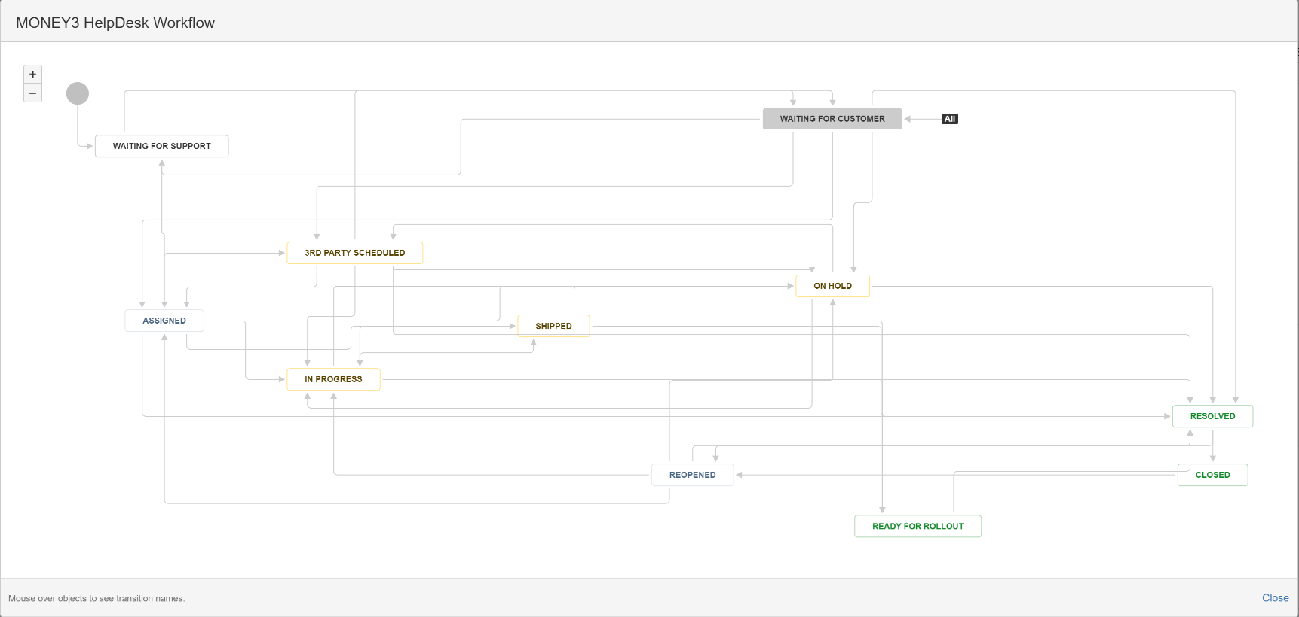

Above is our fancy workflow that I can’t say I fully understand. But practically, the following tips should help you putting a ticket in right stages.

* To assign a ticket at first time, after change assignee you need to click ‘Assign to Agent’ button to finish this stage. Normally help desk will do this for you, but if a ticket assigned to you and you still see that button, just click it to finish this stage.
* Workflow drop down contains stages you can put the ticket in. You normally will start with ‘In Progress’. Set ticket to ‘Resolved’ if the issue has been resolved. Or if you finished work in dev, change the status to ‘Ready to rollout’ and change it to ‘resolved’ after push to production.
* Look at above chart it shows,

1. ‘In progress’ ticket can be put to ‘On hold’, ‘Ready for Rollout’ and ‘Resolved’
2. ‘On hold’ ticket can be put to ‘In progress’, ‘3rd party scheduled’ and ‘Resolved’
3. ‘3rd party’ can be put back to ‘In progress’

* ‘Waiting for customer’ is special one, no matter which stage the ticket is in, you can put it to ‘Waiting for customer’. The ticket can be resolved from this stage, but if you want to change it to ‘In progress’, you need to click ‘Respond to support’ 🡪’Assign to Agent’ to start it again.
* Have no idea what to do with ‘Shipped’ status, my suggestion is don’t ship your tickets☺
* Take some time to look at that workflow, I believe you will find where to go from where you are.

# **IT Project List**

## Permission for developers

All permissions as in Help desk apart from delete issues and modify the reporter.

## Workflow

Same as for Helpdesk

# **Laps, APL Development, APL Bug Fixes**

## Permission for developers

Same as IT Project List, developers are not able to delete issues or modify reporter.

## Workflow

## 

The workflow of these three projects are same or similar to above. You are able to change status to any other status at any point.